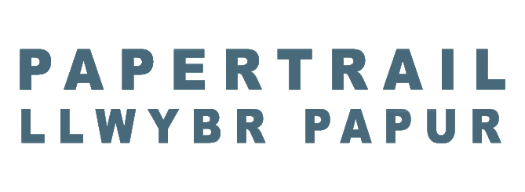
Associate Artist Opportunities with Papertrail
We are seeking two dynamic and passionate Associate Artists to join the company on a part-time ‘residency’ basis from April 2025 for a period of 7 months. During this time you will develop your own new creative project with the support of Papertrail’s Co-Artistic Directors, Jonny Cotsen and Bridget Keehan and contribute to the creative direction of Papertrail.
About Us
Our aim is to dig out untold stories and present them to audiences in engaging ways. Each production blends distinctive writing with adventurous staging. Creative access is core to our work as is our ‘residency’ approach to creating projects. We work closely with communities to find the story that needs to be listened to. We are committed to creating innovative, inclusive work that reflects diverse voices. Our aim is to empower artists to make extraordinary theatre that challenges perceptions and connects with audiences throughout Wales and beyond.
Person Specification
We are looking to support two Welsh or Wales-based artists who are ‘mid-career’ and are seeking the chance to elevate their practice, learn new skills and contribute creatively to Papertrail. You will have a strong creative practice in writing and / or devising / directing theatre but need support in taking your work to the next level.
You will have:
- A strong track record in theatre making, writing, performance, devising and/or directing.
- A passion for championing underrepresented voices and creating inclusive art.
- Excellent communication and facilitation skills, with the ability to engage participants of all abilities and backgrounds.
- Enthusiasm for the work of Papertrail.

You will receive:

A fee of £5,950 for 35 days spread over 7 months
Creative mentorship from Bridget and Jonny
An opportunity to share and develop new skills
The opportunity to work on a Papertrail project
The chance to develop a new creative idea and
support in taking that idea forward.

How to Apply
To apply, please send:
- Your CV (no more than 2 pages) - including links to your work/website.
- An example of your recent work - this could be a production concept (maximum 5 pages) or a script sample (maximum 8 pages) or a link to a short film. Anything you feel best represents your creative voice.
- An accompanying statement (no more than 2 pages / 5 minutes in total) - telling us:
- about your work and what motivates you to create
- why you are interested in working with Papertrail
- what you feel you could gain and what you could contribute as an Associate Artist.
We are committed to removing barriers to participation and welcome applications in any format, including:

- Written documents
- Video or audio recordings
- BSL submissions
If you have any access needs or require assistance during the application process, please get in touch at contact@papertrail.org.uk.
Applications should be sent to contact@papertrail.org.uk by 12 noon Friday 21st March. Shortlisted candidates will be invited to an initial meeting on Friday 28th March.

Access and Inclusion

We are particularly keen to hear from artists who are from communities that are underrepresented in the cultural workforce, particularly when considering disability, class and ethnicity, and people whose lived experience reflects the communities we work with.

